**Lab : 6**

**Write a C program to add two matrics.**

Program

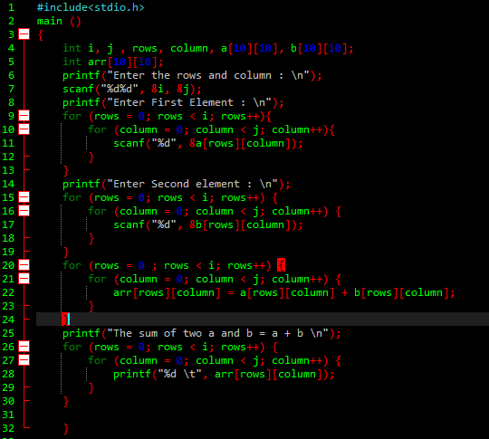

Output

